**Communication and cross-curricular teaching.**

**Enhancing awareness**

*Handle is optional on all exercises* but may be useful for providing support to adult when assisting in certain exercises.*

*\* (Except for grade 3 exercises where handle should be removed)*

[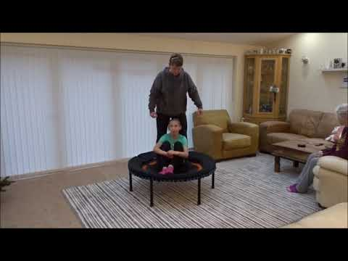](https://www.youtube.com/watch?v=y-meG5M0HB8)

If the link in the video thumbnail above does not play the video on your device, please use this web page to view:   
<https://www.youtube.com/watch?v=y-meG5M0HB8>

Grade 1, Exercise 1: Sits facing adult in stillness

Grade 1, Exercise 2: Differentiates stillness and movement

Grade 1, Exercise 3: Anticipates cause and effect

Grade 1, Exercise.4: Waits patiently for turn

Grade 1, Exercise 5: Maintains eye contact when appropriate

Grade 1, Exercise.8: Enjoys being bounced in sitting position

Grade 1, Exercise.9: Sitting position - initiates movement by pushing into bed with hands

Grade 1, Exercise 9.1: Sitting and bouncing - pointing to colours, numbers, letters, shapes, animals

Grade 1, Exercise 10: Sitting position - swimming arm movement to initiate bounce

Grade 1, Exercise.15: Standing in stillness with feet flat on bed

Grade1, Exercise 16: Standing position - maintains shape while being gently bounced

Grade 1, Exercise.17: Standing position - initiate bounce (bobble)

Grade 2, Exercise 6: Quarter turns in sitting position

Grade 2, Exercise 6.1: Quarter turns in sitting position - teach left and right

Grade 2, Exercise 9: Perform 3 bounces - stop - stillness

Grade 2, Exercise 9.1: Perform 4, 5, 6, 7 bounces etc. - stop - stillness

Grade 2, Exercise 10: Standing position - bounce with quarter twists

Grade 2, Exercise 11: Standing position - bounce with quarter twists, performs left and right

Grade 2, Exercise 11.1: Standing position - bounce with twist - teach clockwise, anticlockwise, clock numbers, compass points